**User Dashboard Comments:**

1. Login button size should be consistent with sign up size

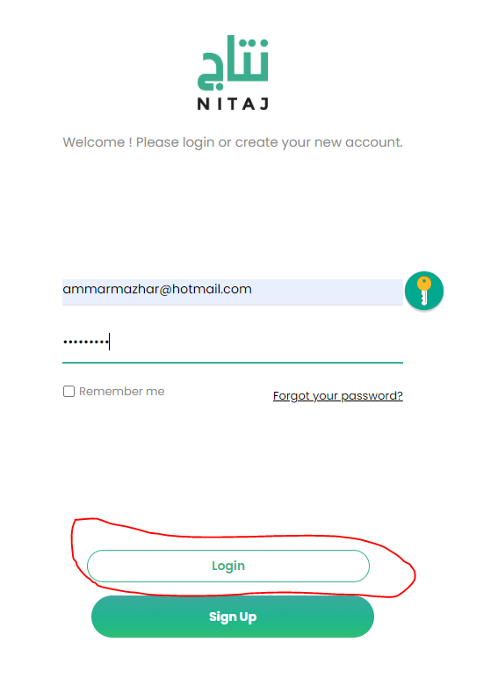

1. Cannot return to application if skipped , we need a button showing that the application is not yet complete and the user can access the incomplete application.
2. Dashboard menu bar is not complete ( logo on top, icons, Share listing, and my wallet)

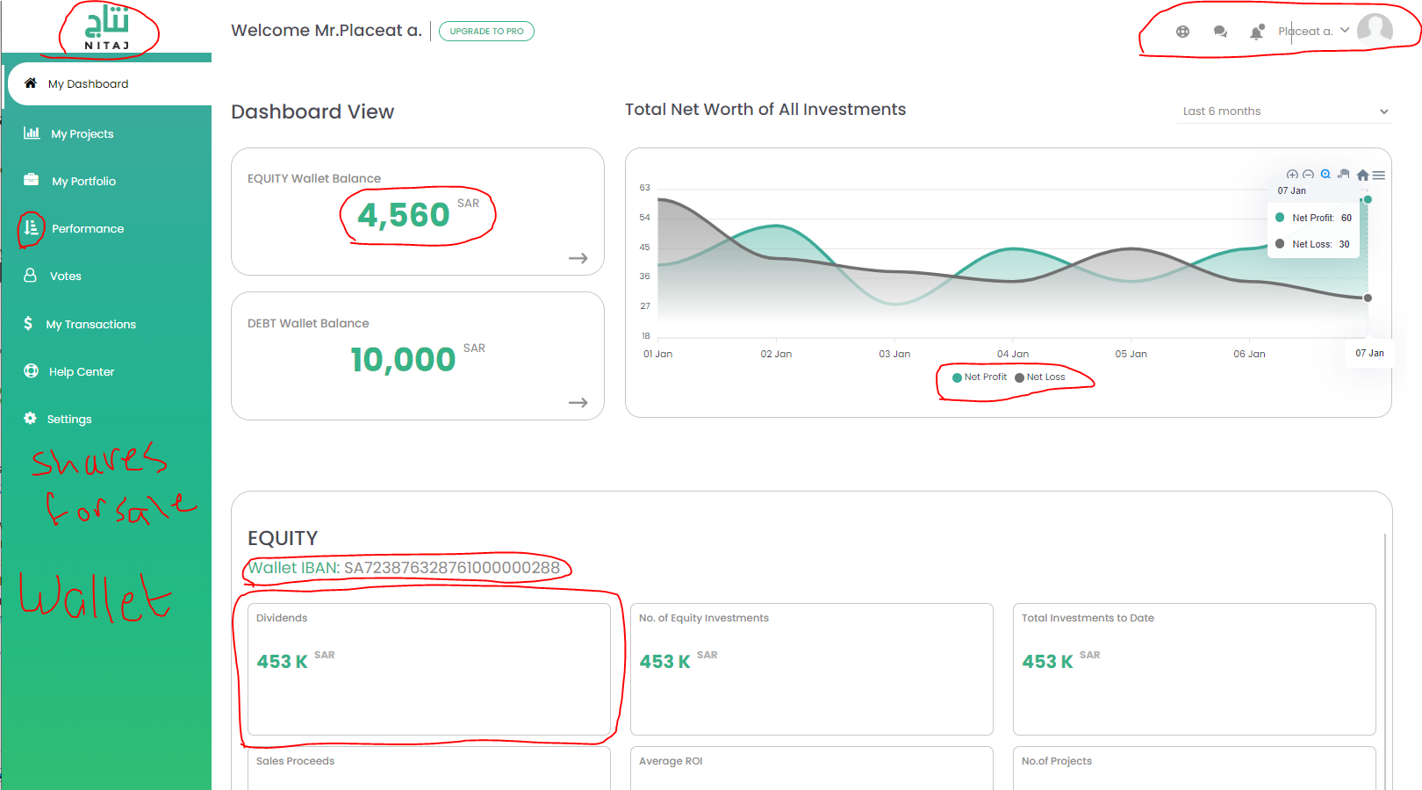

1. I want to make sure green text does not have gray stroke
2. Performance Icon needs to be rotated to show the arrow pointing to the right
3. Menu bar is missing My wallet and Share Listing. Remember Jeff included my transactions inside the wallet.
4. Loading Circle between screens is in very low resolution.
5. Dashboard graph legend (Dividends, Account value, deposits, withdrawals)
6. Box sizes relative to numbers in equity and debt sections, please revise this section:

Dashboard Comments:

**Discussion on Investor Dashboard Screen:**

Following is the data that should be in every section

Equity: (Total Invested (SAR), Dividends (SAR), Sales Proceeds (SAR), Unrealized Returns (SAR), Realized Returns (SAR), Average Annual Return (%)

Debt: Total Invested (SAR), No. of Investments( Number), Average Annual Return (%), Unrealized Returns (SAR), Realized Returns (SAR), Withdrawals (SAR) .

Regular investors will have a cap of 200,000 SAR per year for the equity. For the pro investor, no cap for equity

Debt: Cap for regular investor is 10,000 per opportunity, and 100,000 per year (These values are subject to change according to the regulator so these should be easy to edit)

For professional investors for DEBT is still not yet determined by the regulator

For the IBANS you can click a button to show it. If the button is clicked it should show the Bank name Anb Bank, logo, and Iban no. The current screen is not showing any bank info of this IBAN as the API integration has not been taken care of in this document. Maybe we can make it as a button called View IBAN

Note: This is from page 15 in SRS.

1. Top menu bar in dashboard view is messed up there is a line intersecting with the text



1. Drop down selection boxes include the default text. The default text should not show as an option. I will discuss an example.
2. Random Line in the Equity box ( far to the right)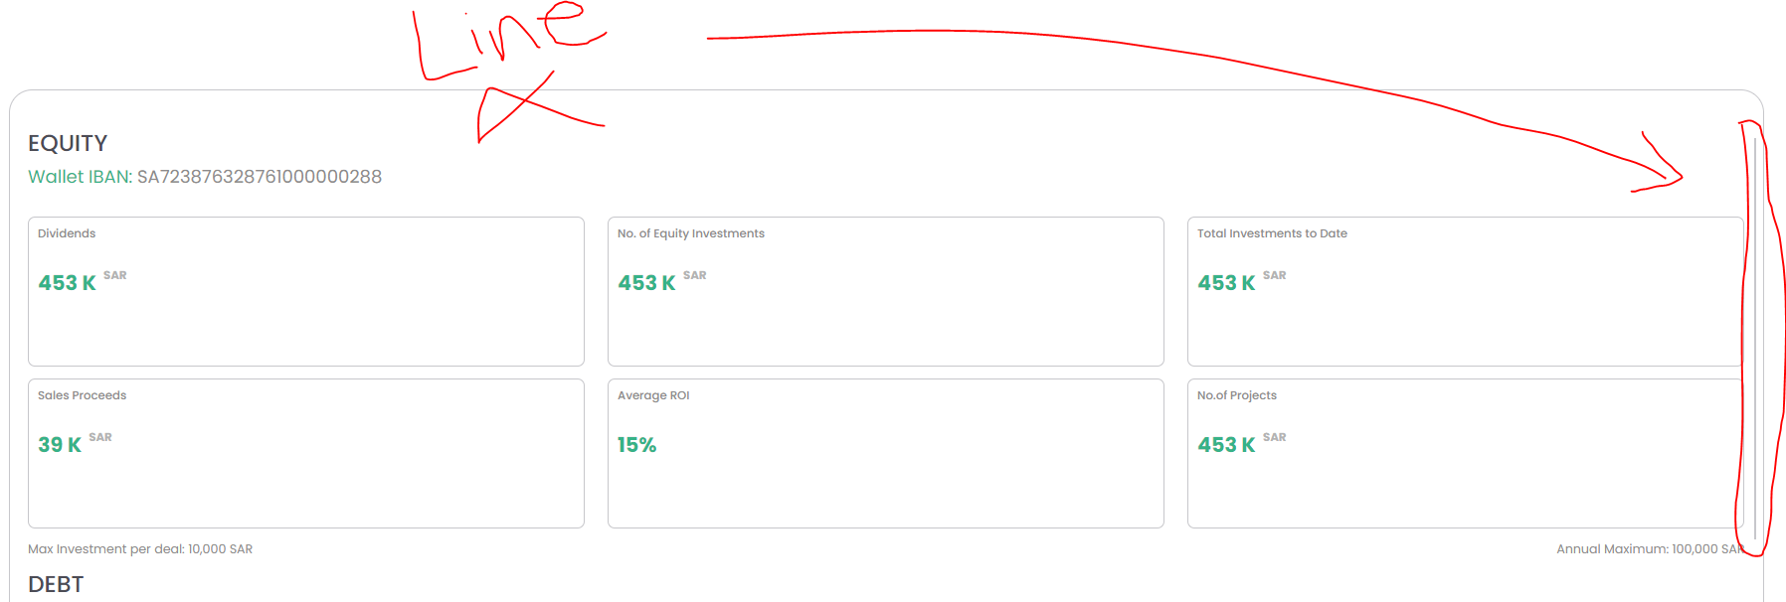
3. Recent Activity (Active projects or view all) I would suggest that we just keep it as view all. The user will only see activity to their invested projects or general news that anyone can see.
4. +966 in the registration disappears when we fill in the text that needs fixing. The +966 should not disappear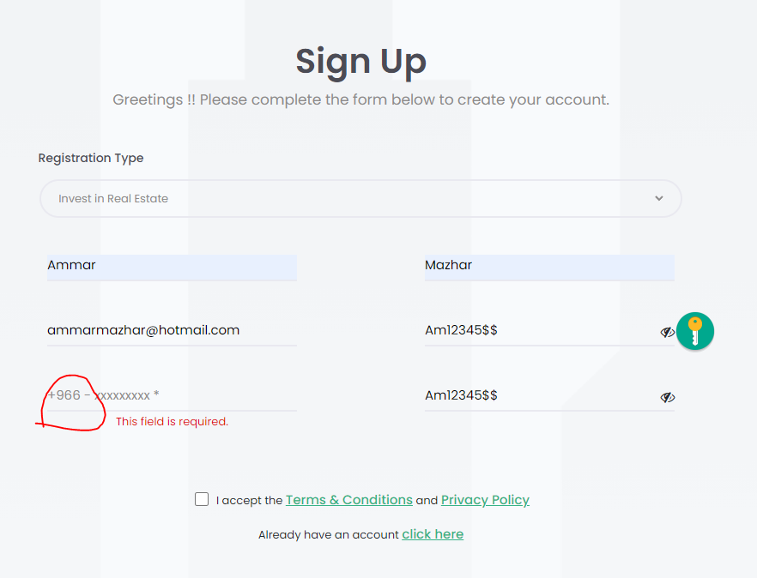
5. Labeling on the boxes when filling an application should not disappear as well when filling it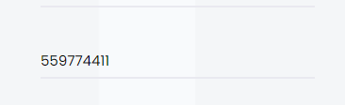
6. Selection boxes can all be under each other. It might look better and easier for a better user experience. 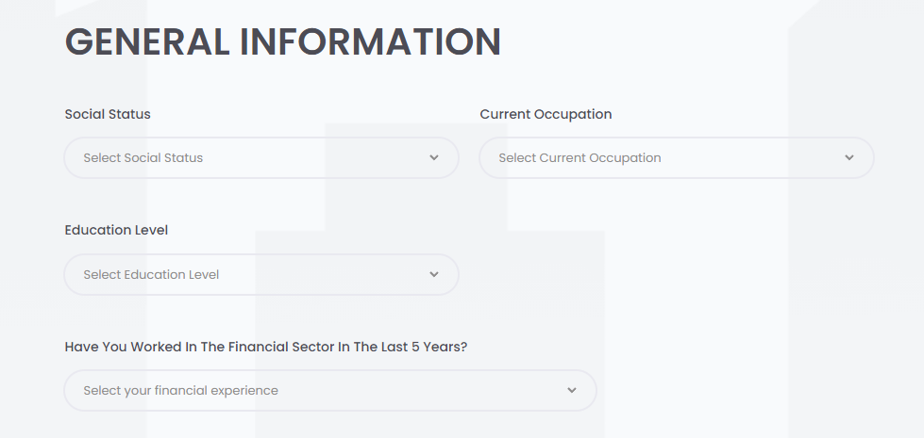
7. Progress bar showing the application complete sections can be edited to avoid having two lines of text for the address ( ID Info, ID & Address Verification, General Info, Financial Status)

**Admin Dashboard Comments:**

1. **Menu Bar should be edited**
2. **Dashboard should be edited and should not be identical to the user dashboard.**
3. **Categories section will have to be edited according to the following instructions:**

* **Main Categories**
* Development - تطوير
* Acquisition- استحواذ

**Sub Categories**

* Equity- ملكية
* Debt- دين
* **Property Type**
* Residential
  + Villas- فلل
  + Apartment-شقة
  + Studio- ستوديو
  + Townhouse - تاون هاوس
  + Apartment Building - عمارة سكنية
  + Compound- مجمع فلل
* Commercial
  + Apartment Complex- مجمع عمائر سكنية
  + Villa Compound- مجمع فلل
  + Industrial - مستودعات صناعية
  + Office Building - برج مكاتب
  + Hotels- فنادق
  + Medical - مجمع طبي
  + Vacation Home - بيوت للعطلة
* Type instead of property type ( because acquisition or development is not a property type, its a project type)
* Arabic should not be from a selection bar. I need a text field to insert it manually please.

